Date: 23-09-21
WEBLEM 4
Introduction to Protein Sequence Database

Introduction:

- Uniprot:

The Universal Protein Resource (UniProt) is a comprehensive resource for protein sequence and annotation data. The UniProt databases are the UniProt Knowledgebase (UniProtKB), the UniProt Reference Clusters (UniRef), and the UniProt Archive (UniParc). The UniProt consortium and host institutions EMBL-EBI, SIB and PIR are committed to the long-term preservation of the UniProt databases.

- UniprotKb:

The UniProt Knowledgebase (UniProtKB) is the central hub for the collection of functional information on proteins, with accurate, consistent and rich annotation. In addition to capturing the core data mandatory for each UniProtKB entry (mainly, the amino acid sequence, protein name or description, taxonomic data and citation information), as much annotation information as possible is added.

Reviewed(Swiss-Prot)-Manually annotated: Records with information extracted from literature and curator-evaluated computational analysis.

Unreviewed(TeEMBL)-Computationally analyzed: Record that await full manual annotation.

- Uniref:

The UniProt Reference Clusters (UniRef) provide clustered sets of sequences from the UniProt Knowledgebase (including isoforms) and selected UniParc records. This hides redundant sequences and obtains complete coverage of the sequence space at three resolution

- UniParc:

UniParc is a comprehensive and non-redundant database that contains most of the publicly available protein sequences in the world. Proteins may exist in different sources databases and in multiple copies in the same database. UniParc avoids such redundancy by storing each unique only once and giving it a stable and unique identifier (UPI)

- Proteomes:

A proteome is the set of proteins thought to be expressed by an organism. UniProt provides proteomes for species with completely sequenced genomes.

- PIR:

The Protein Information Resource (PIR) is an integrated public bioinformatics resource to support genomic, proteomic and systems biology research and scientific studies.

PIR was established in 1984 by the National Biomedical Research Foundation (NBRF) as a resource to assist researchers in the identification and interpretation of protein sequence information. Prior to that, the NBRF compiled the first comprehensive collection of macromolecular sequences in the Atlas of Protein Sequence and Structure, published from 1965-1978 under the editorship of Margaret). Dayhoff. Dr. Dayhoff and her research group pioneered in the development of computer methods for the comparison of protein sequences, for the detection of distantly related sequences and duplications within sequences, and for the inference of evolutionary histories from alignments of protein sequences.

- PRO:
PRO provides an ontological representation of protein-related entities by explicitly defining them and showing the relationships between them. Each PRO term represents a distinct class of entities (including specific modified forms, orthologous isoforms, and protein complexes) Ranging from the taxon-neutral to the taxon-specific.

- IPTMnet:

iPTMnet is a bioinformatics resource for integrated understanding of protein post-translational modification (PTMs) in systems biology context.

It connects multiple disparate bioinformatics tools and systems text mining, data mining, analysis and visualization tools, and databases and ontologies into an integrated cross-cutting research resource to address the knowledge gaps in exploring and discovering PTM networks.

- IproLINK:

iProLINK (integrated Protein Literature, Information and knowledge) is resource with access to text mining tools and annotated corpora developed in house. The collection of data sources can be utilized by computational and biological researches to explore literature information on proteins and their feature or properties.

- ItextMine: Integrated text mining tools and relation extraction results from large-scale text processing.
- pGenN: a gene normalization tool tailored for plants.
- MiRTex: a relation extraction tool that identifies miRNA-target relations as well as miRNA-gene and gene-miRNA regulation relations.
- EFIP: A relation extraction tool that identifies information relevant to phosphorylated proteins and phosphorylation-dependent protein-protein interactions.
- EmiRIT: an integrative text mining system collecting miRNA information from the literature.
- RLIMS-P: a generalizable relation extraction system (for developers)
- iSimp: a sentence simplification system (for developers)

Date: 29-09-21
WEBLEM 4a
(URL: https://www.uniprot.org/)

Aim:

To study ‘Rhodopsin’ Protein information using UniProt Database.

Introduction:

The UniProt Knowledgebase (UniProtKD) is the central hub from the collection of functional information on proteins, with accurate, consistent and rich annotation. In addition to capturing the core data mandatory for each UniProtKB entry (mainly the amino acid sequence, protein name or description, taxomic data and citation information), as much annotation information as possible in added.

Rhodopsin is a biological pigment found in the rods of the retina and is a G-protein-coupled receptor (GPCR). It belongs to a group of photoswitchable opsins. Rhodopsin is extremely sensitive to light, and thus enables vision in low-light conditions. When rhodopsin is exposed to light, it immediately photobleaches.

Methodolgy:

- Homepage of Uniprot.
- Enter the UniprotKB and search the query ‘Rhodopsin’
- Interpret the results.

Observations:
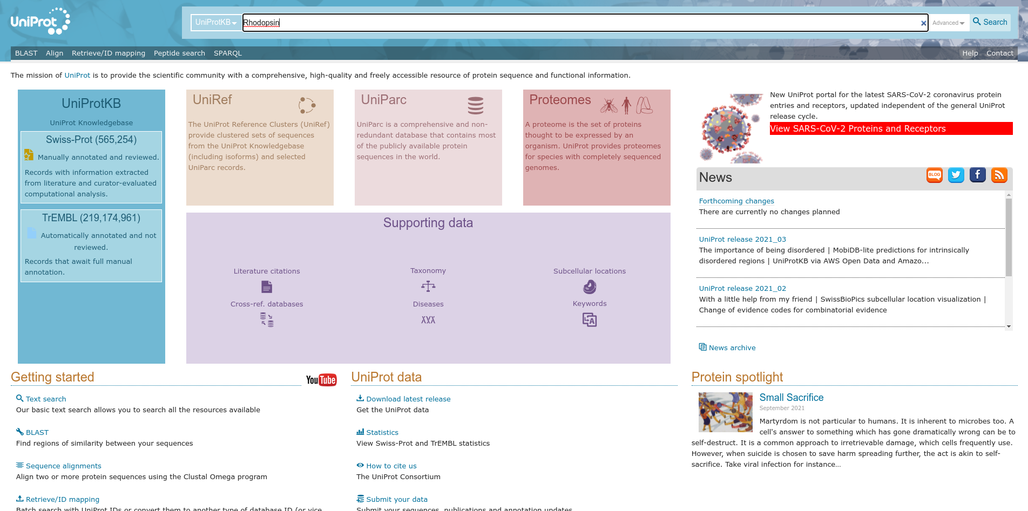
Fig1. Homepage of Uniprot with query ‘Rhodopsin’

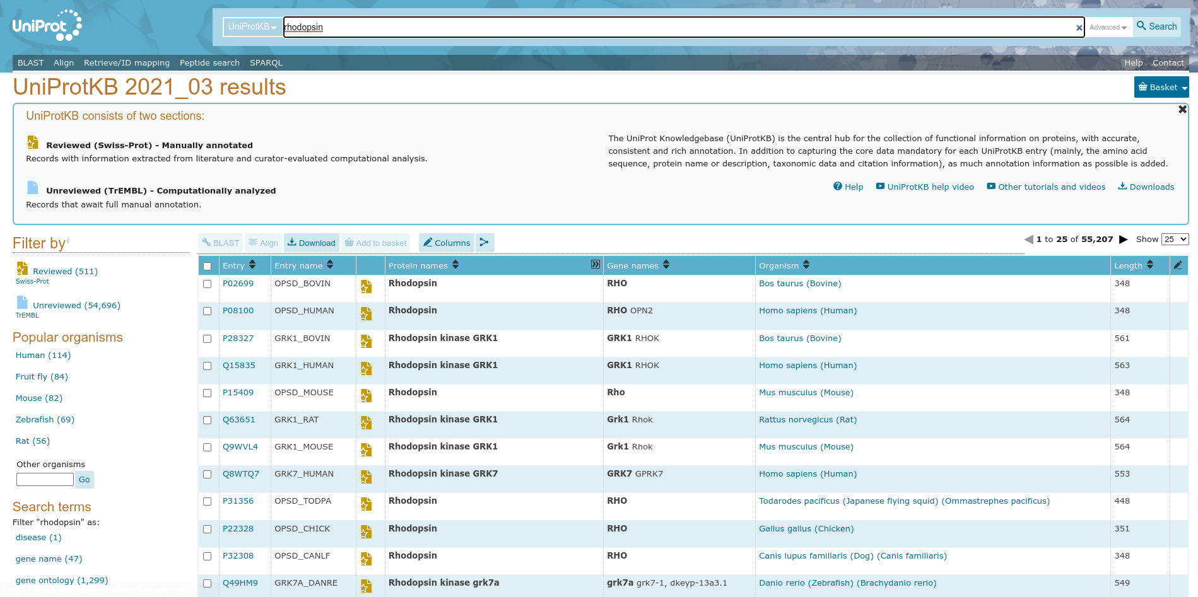
Fig2. Hit page of UniprotKB with query ‘Rhodopsin’

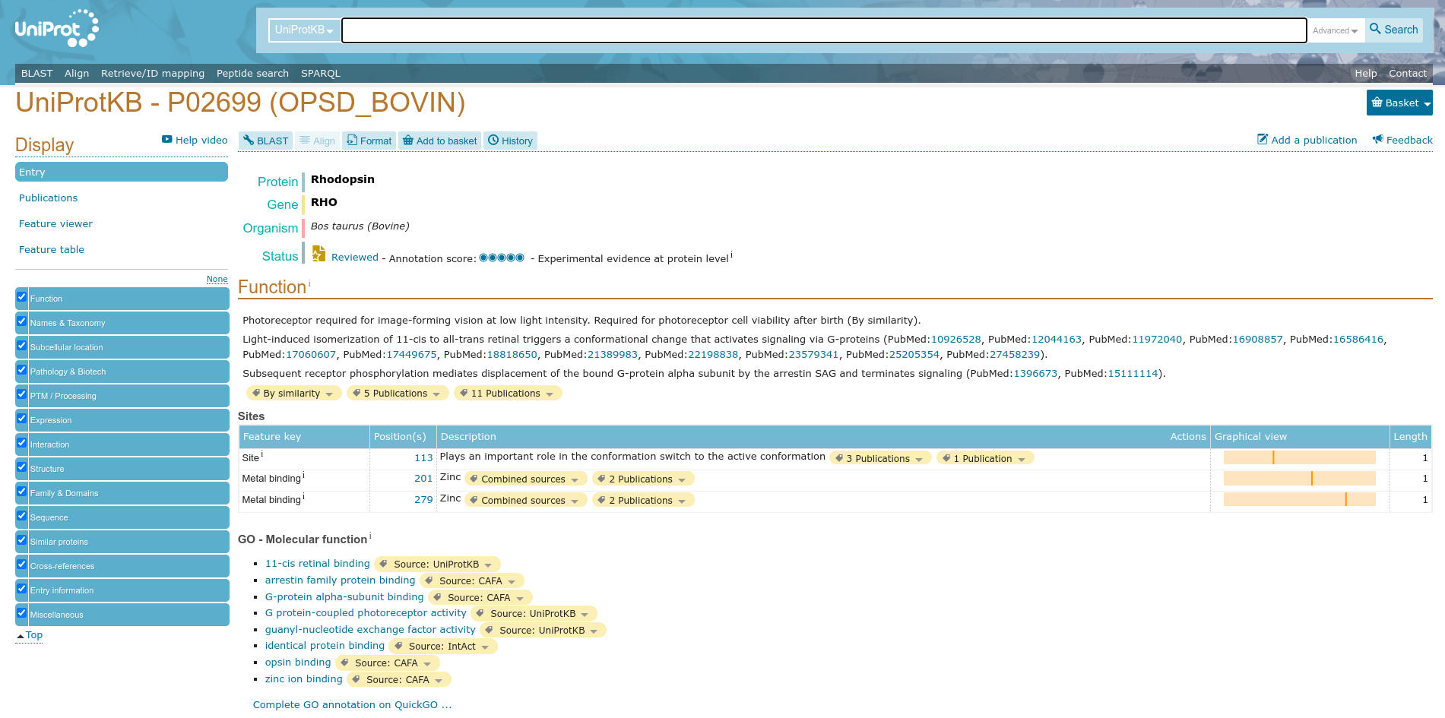
Fig3. Header page with of result with query ‘Rhodopsin’

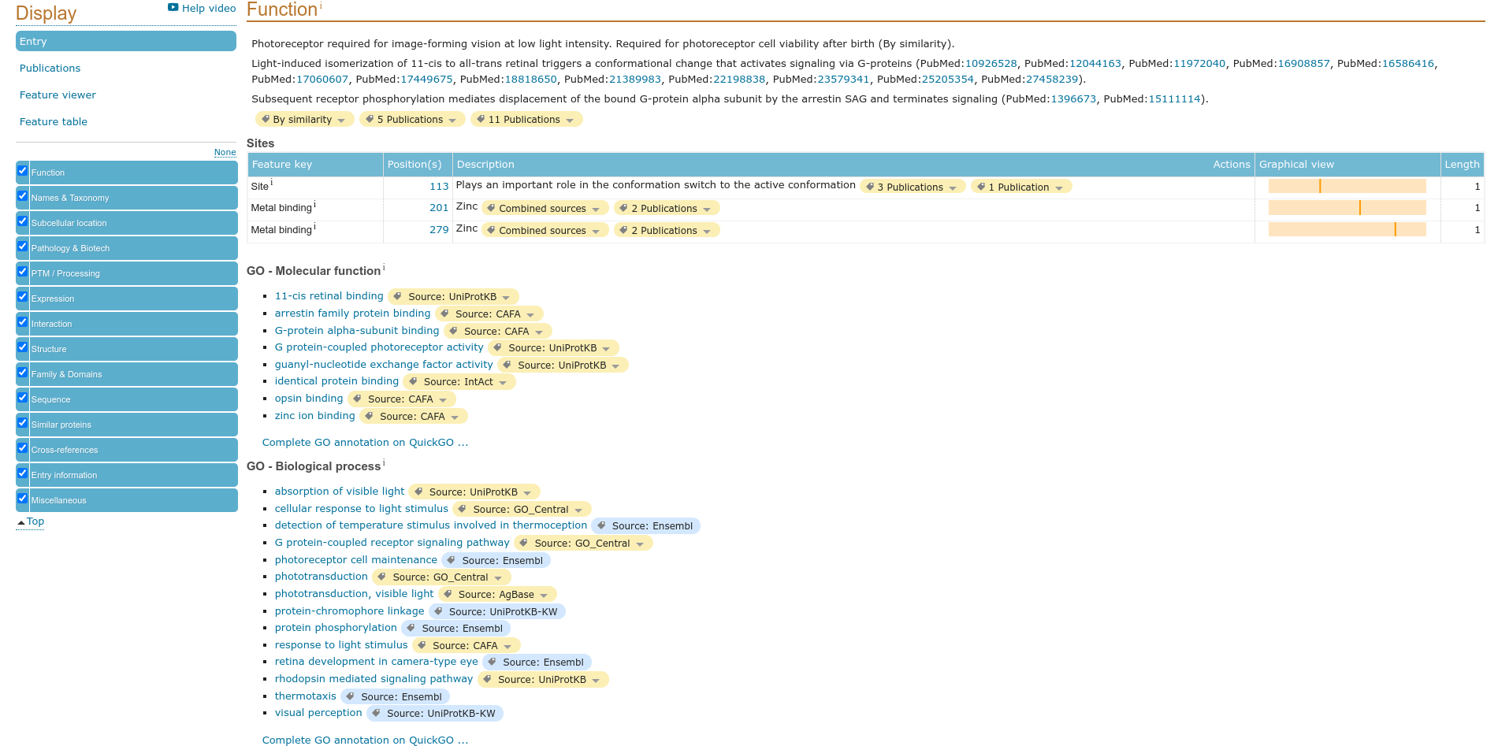
Fig4. Function page of result for query ‘Rhodopsin’

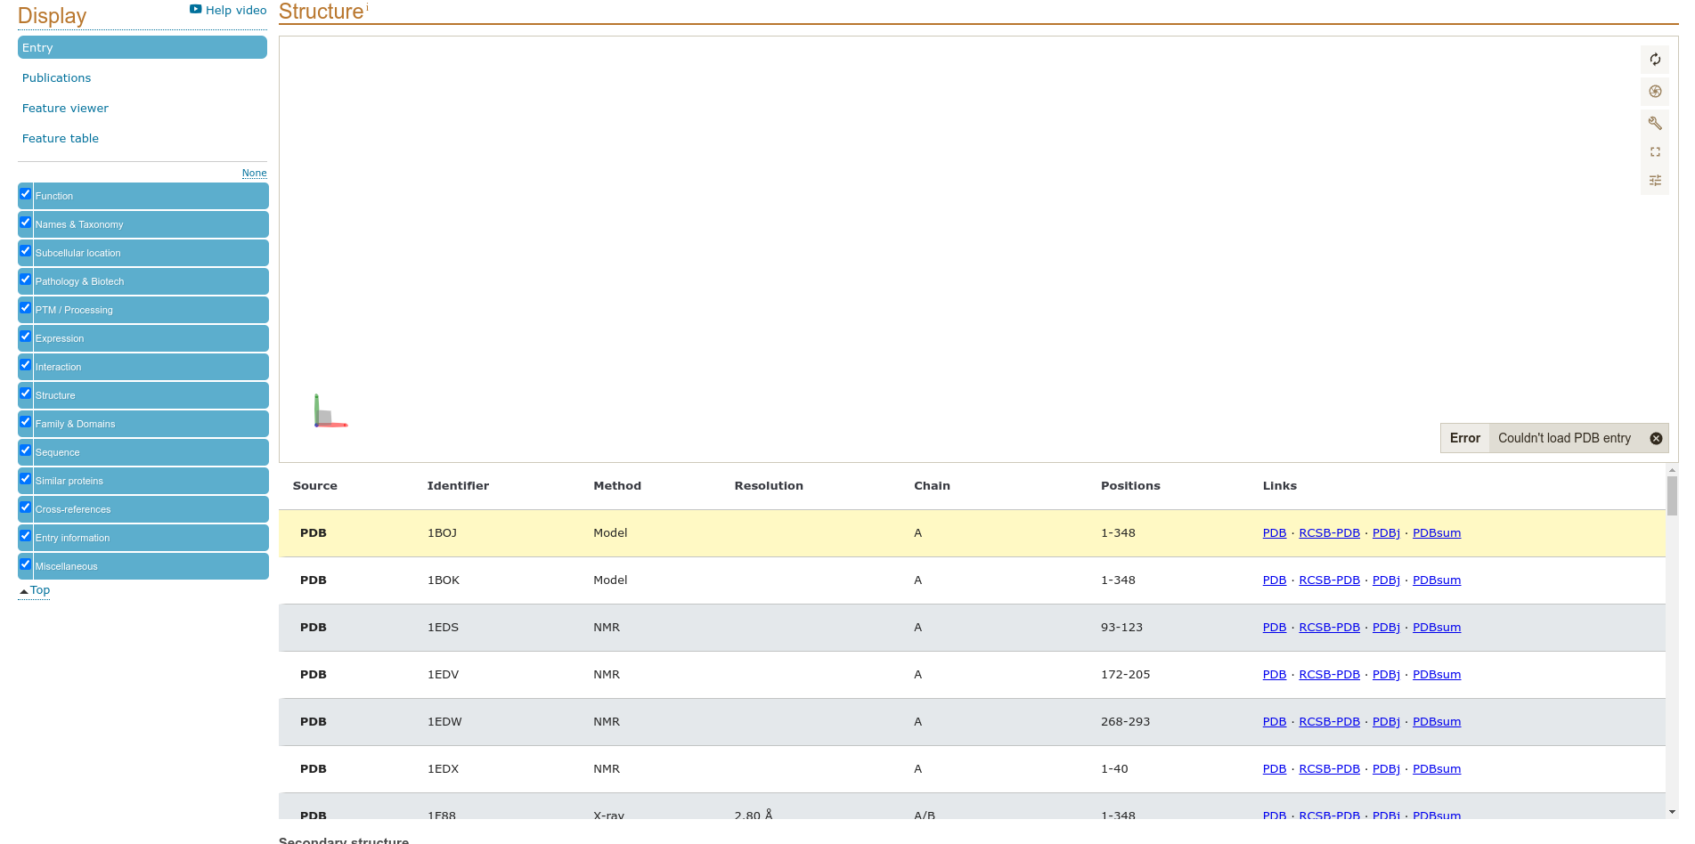
Fig5. Structure of result of query ‘Rhodopsin’

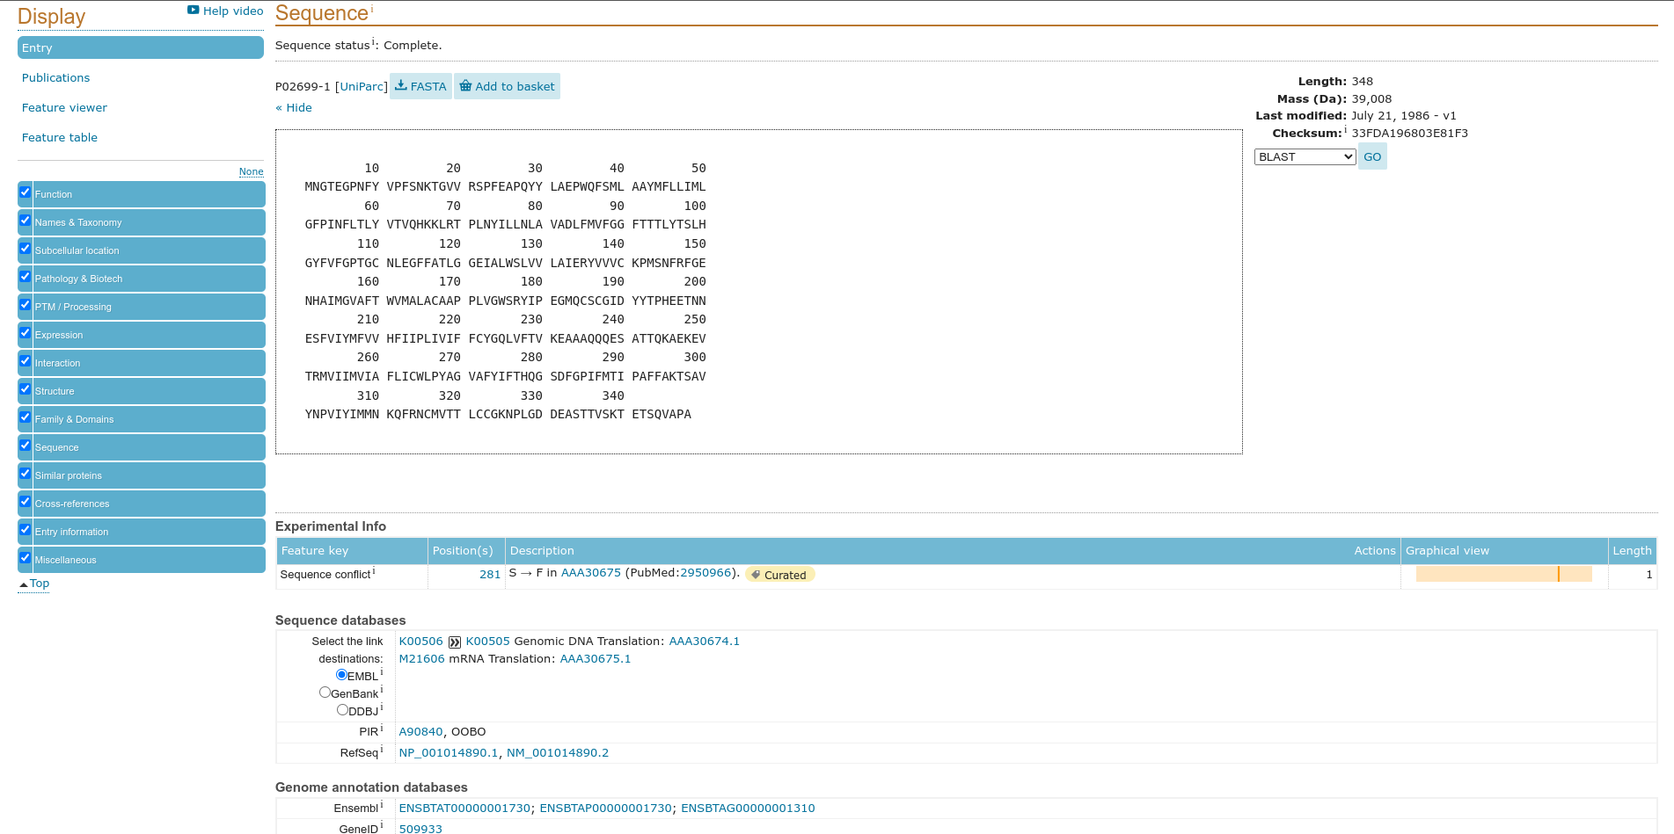
Fig6. Sequences of result for query ‘Rhodopsin’

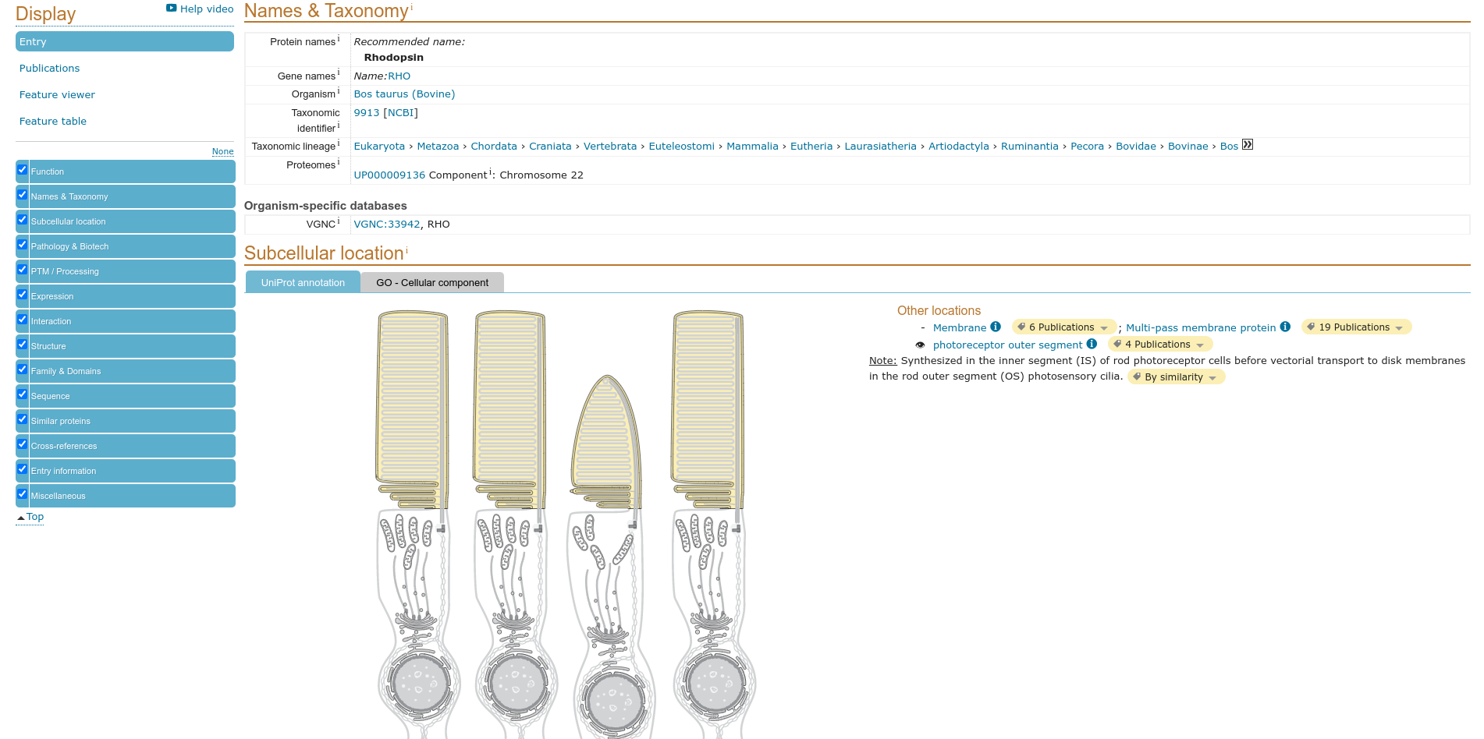
Fig7. Names and taxonomy of result for query ‘Rhodopsin’

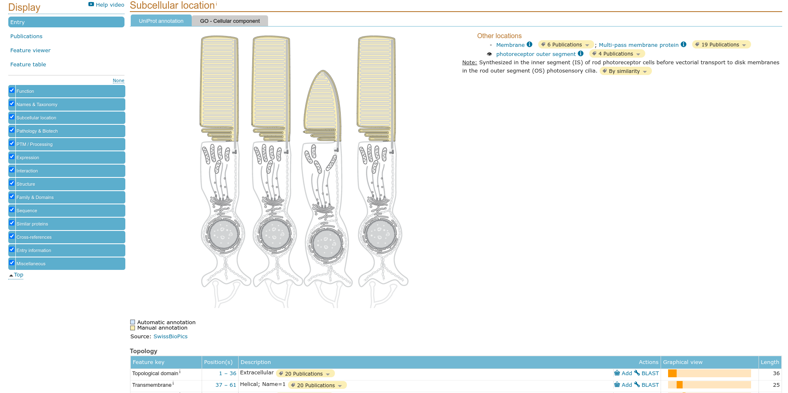
Fig8. Subcellular location of result for query ‘Rhodopsin’

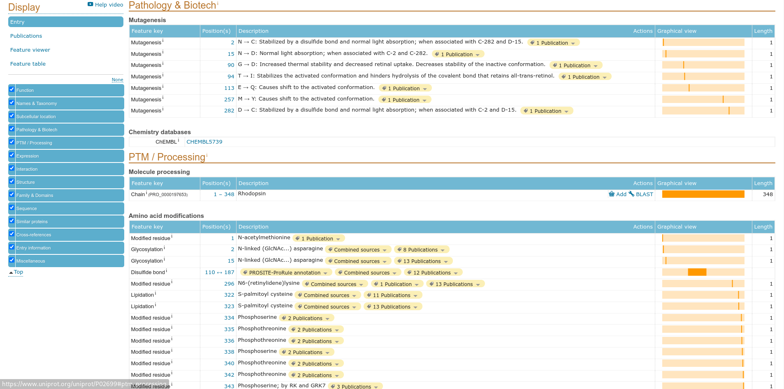
Fig9. Pathology and Biotech of result for query ‘Rhodopsin’

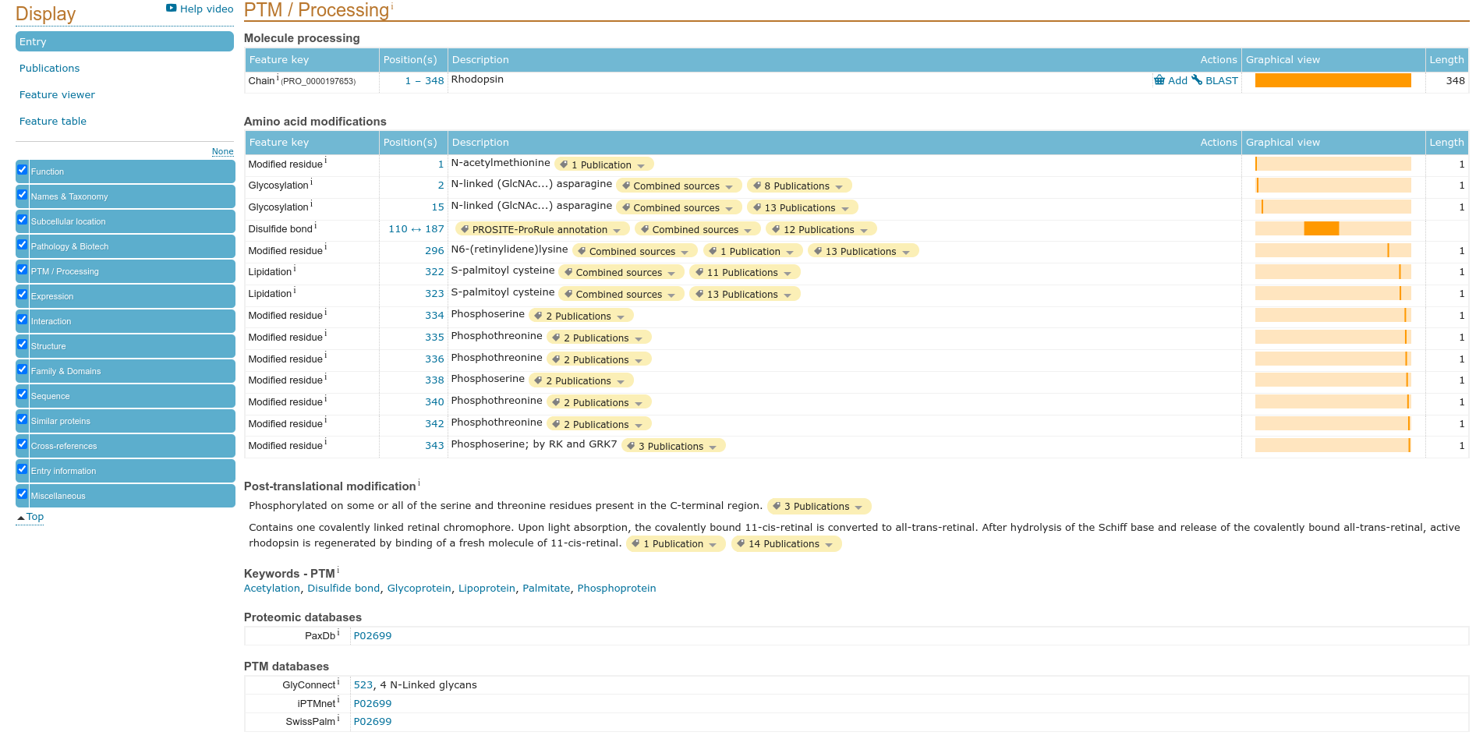
Fig10. PTM/Processing of result for query ‘Rhodopsin’

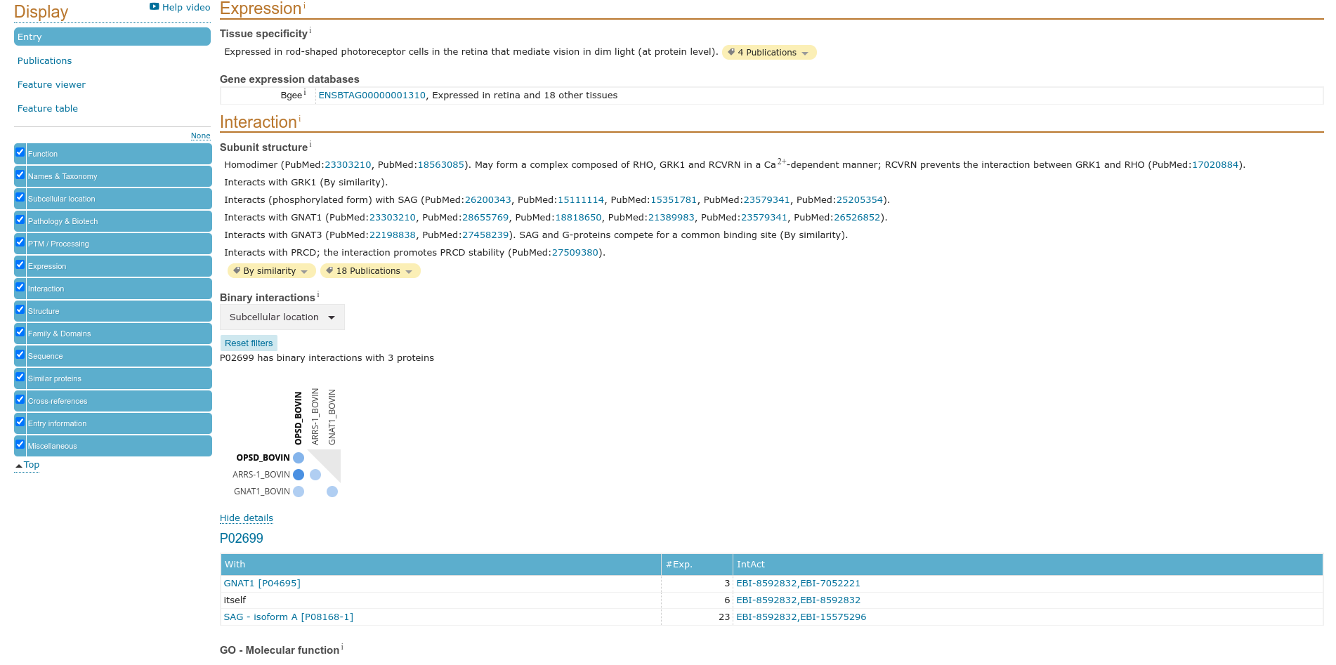
Fig11. Expression / Interaction for result of query ‘Rhodopsin’

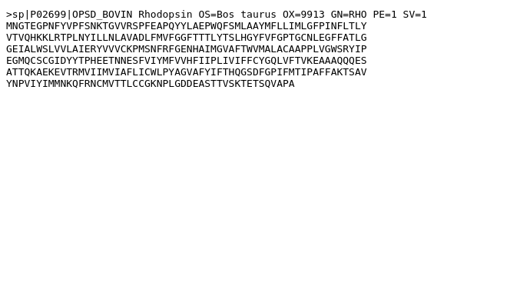
Fig12. Fasta Cananical for result for query ‘Rhodopsin’

Results:

UniProt is a freely accessible database of protein sequence and functional information, many entries being from genome sequence projects. It contains a larga amount of information about the biological function of proteins dereived from the research literatures.

Conclusions:

Uniprot is a biological database for protein and it has all information regarding the protein sequences, protein structures and UniProt can use as a cross references.

References:
- https://www.uniprot.org/
- https://www.uniprot.org/uniprot/?query=Rhodopsin&sort=score
- https://www.uniprot.org/uniprot/P02699#function
- https://www.uniprot.org/uniprot/P02699#names_and_taxonomy
- https://www.uniprot.org/uniprot/P02699#subcellular_location
- uniprot.org/uniprot/P02699#pathology_and_biotech
- https://www.uniprot.org/uniprot/P02699#ptm_processing
- https://www.uniprot.org/uniprot/P02699#expression
- https://www.uniprot.org/uniprot/P02699#structure
- https://www.uniprot.org/uniprot/P02699#sequences
- https://www.uniprot.org/uniprot/P02699.fasta

Date: 29-09-21
WEBLEM 4b
(URL: https://www.uniprot.org/)

Aim:

To study ‘Rhodopsin’ Protein information using SwissProt Database: Reviewed and Manually annotated Database.

Introduction:

SWISS-PROT is a curated protein sequence database which strives to provide a high level of annotation (such as the description of the function of a protein, its domains structure, post-translational modifications, variants, etc.), a minimal level of redundancy and high level of integration with other databases.

Rhodopsin is a biological pigment found in the rods of the retina and is a G-protein-coupled receptor (GPCR). It belongs to a group of photoswitchable opsins. Rhodopsin is extremely sensitive to light, and thus enables vision in low-light conditions. When rhodopsin is exposed to light, it immediately photobleaches.

Methodolgy:

- Homepage of Uniprot.
- Enter the UniprotKB and search the query ‘Rhodopsin’
- Interpret the results.

Observations:
Fig1. Homepage of Uniprot with query ‘Rhodopsin’

Fig2. Hit page of UniprotKB with query ‘Rhodopsin’

Fig3. Header page with of result with query ‘Rhodopsin’

Fig4. Function page of result for query ‘Rhodopsin’

Fig5. Structure of result of query ‘Rhodopsin’

Fig6. Sequences of result for query ‘Rhodopsin’

Fig7. Names and taxonomy of result for query ‘Rhodopsin’

Fig8. Subcellular location of result for query ‘Rhodopsin’

Fig9. Pathology and Biotech of result for query ‘Rhodopsin’

Fig10. PTM/Processing of result for query ‘Rhodopsin’

Fig11. Expression / Interaction for result of query ‘Rhodopsin’

Fig12. Fasta Cananical for result for query ‘Rhodopsin’

Results:

In UniprotKB it consist SwissProt that is Reviewed paper and for the query ‘Rhodopsin’ is
contain 511 papers .

Conclusions:

Uniprot is a biological database for protein and it has all information regarding the protein sequences, protein structures and UniProt can use as a cross references.

References:
- https://www.uniprot.org/
- https://www.uniprot.org/uniprot/?query=Rhodopsin&sort=score
- https://www.uniprot.org/uniprot/P02699#function
- https://www.uniprot.org/uniprot/P02699#names_and_taxonomy
- https://www.uniprot.org/uniprot/P02699#subcellular_location
- https://uniprot.org/uniprot/P02699#pathology_and_biotech
- https://www.uniprot.org/uniprot/P02699#ptm_processing
- https://www.uniprot.org/uniprot/P02699#expression
- https://www.uniprot.org/uniprot/P02699#structure
- https://www.uniprot.org/uniprot/P02699#sequences
- https://www.uniprot.org/uniprot/P02699.fasta

Date: 29-09-21
WEBLEM 4c
(URL: https://www.uniprot.org/)

Aim:

To study ‘Rhodopsin’ Protein information using TrEMBL Database: Unreviewed and manually annotated Database.

Introduction:

UniProtKB/TrEMBL is a computer-annotated protein sequence database complementing . UniProtKB/TrEMBL contains the translations of all coding sequences (CDS) present in the EMBL/GenBank/DDBJ Nucleotide Sequence Databases and also protein sequences extracted. The database is enriched with automated classification and annotation.

Rhodopsin is a biological pigment found in the rods of the retina and is a G-protein-coupled receptor (GPCR). It belongs to a group of photoswitchable opsins. Rhodopsin is extremely sensitive to light, and thus enables vision in low-light conditions. When rhodopsin is exposed to light, it immediately photobleaches.

Methodolgy:
- Homepage of Uniprot.
- Enter the UniprotKB and search the query ‘Rhodopsin’
- Open Unreviewed paper.
- Interpret the results.

Observations:
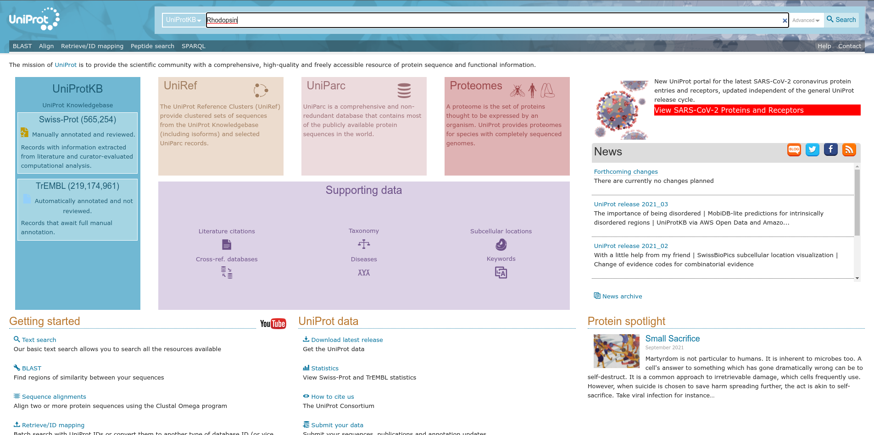
Fig1. Homepage for Uniprot with query Rhodopsin

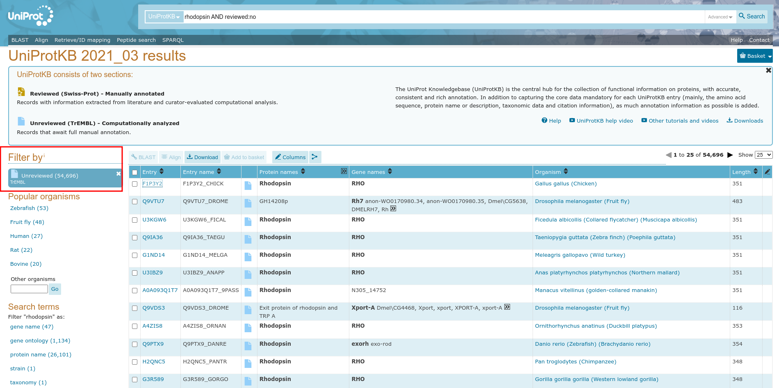
Fig2. Hit page for Unreviewed for query Rhodopsin

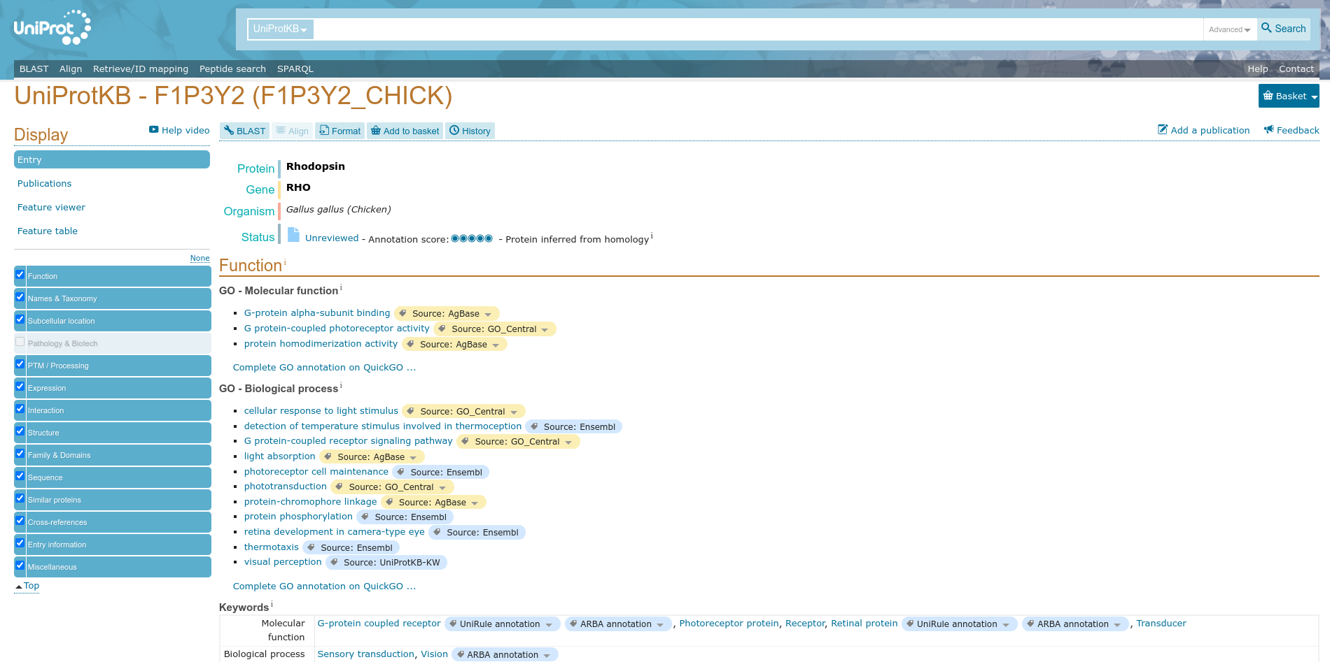
Fig3. Header page for query Rhodopsin

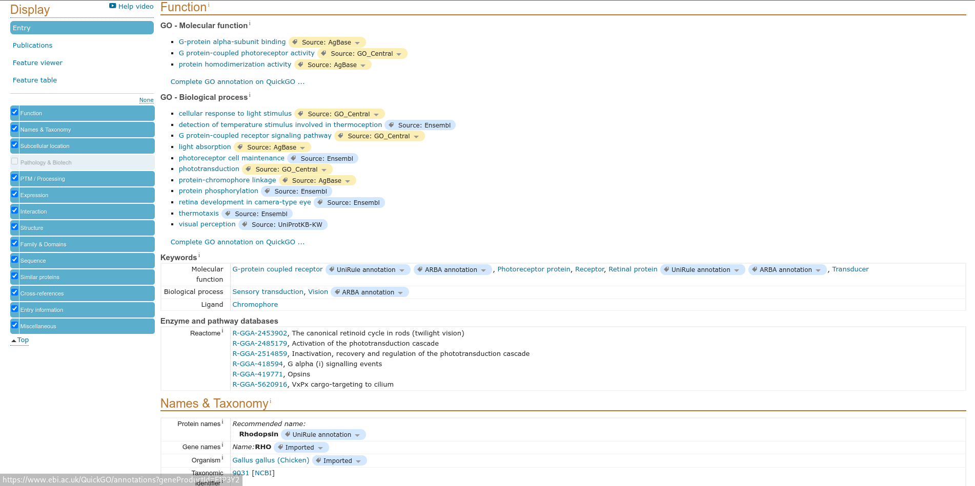
Fig4. Function page for query Rhodopsin

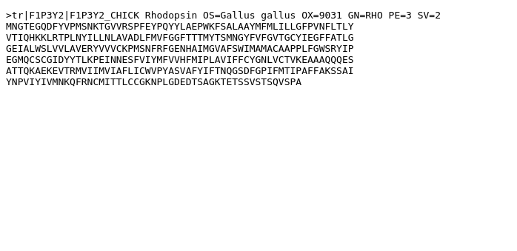
Fig5. FASTA Cananical for result page of query Rhodopsin

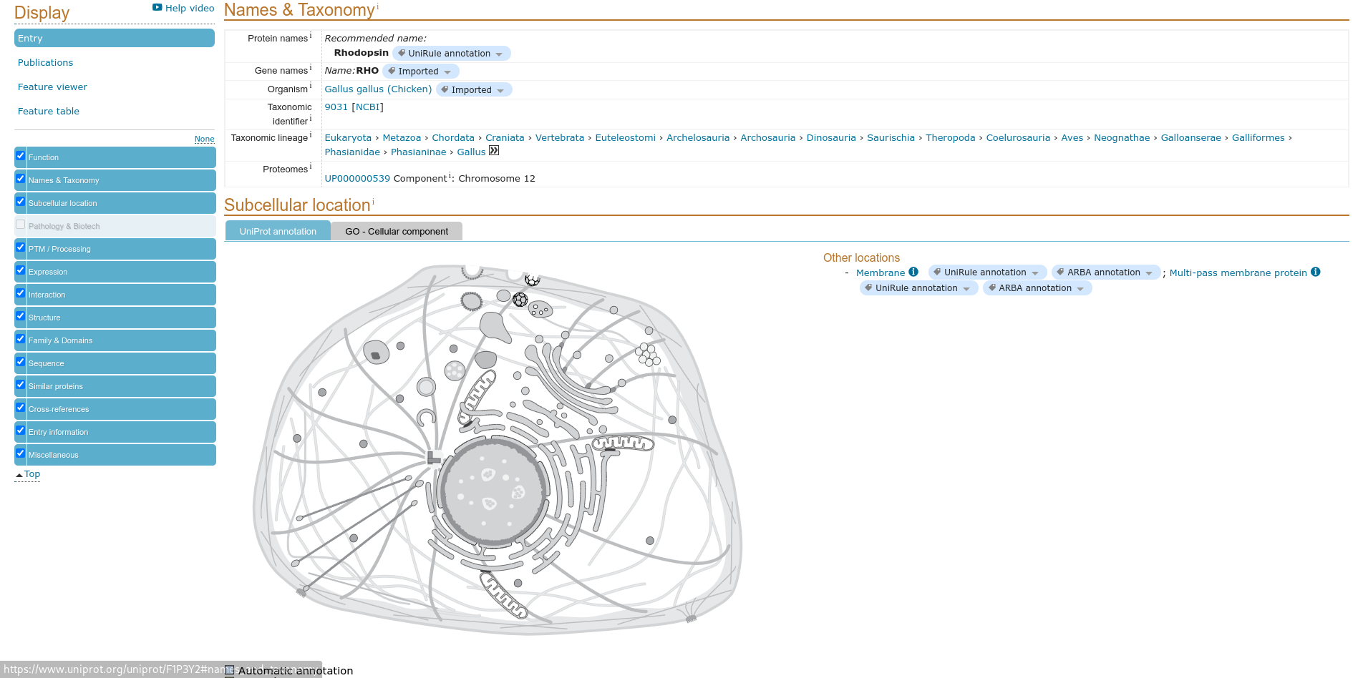
Fig6. Names and Taxonomy of result page for query Rhodopsin

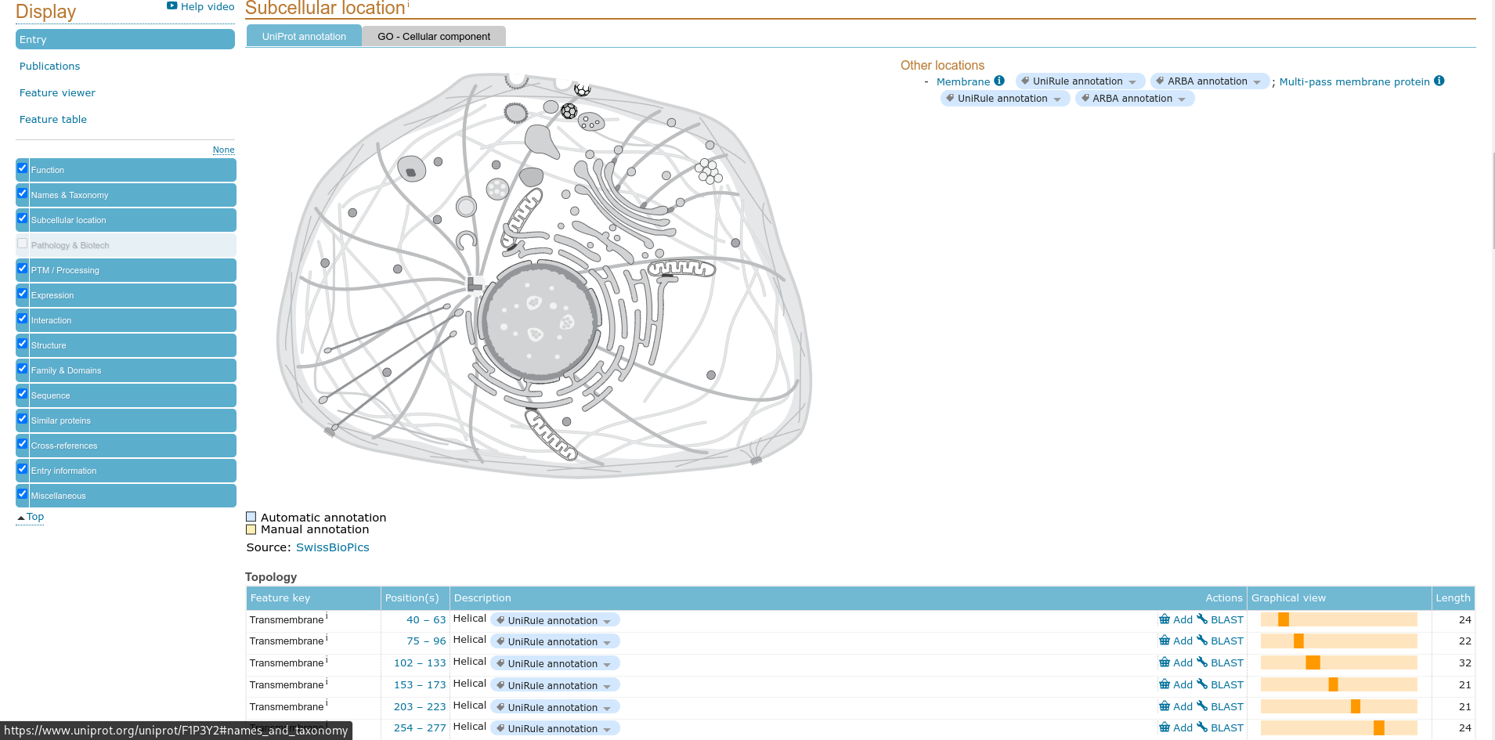
Fig7. Subcellular location of result page for query Rhodopsin

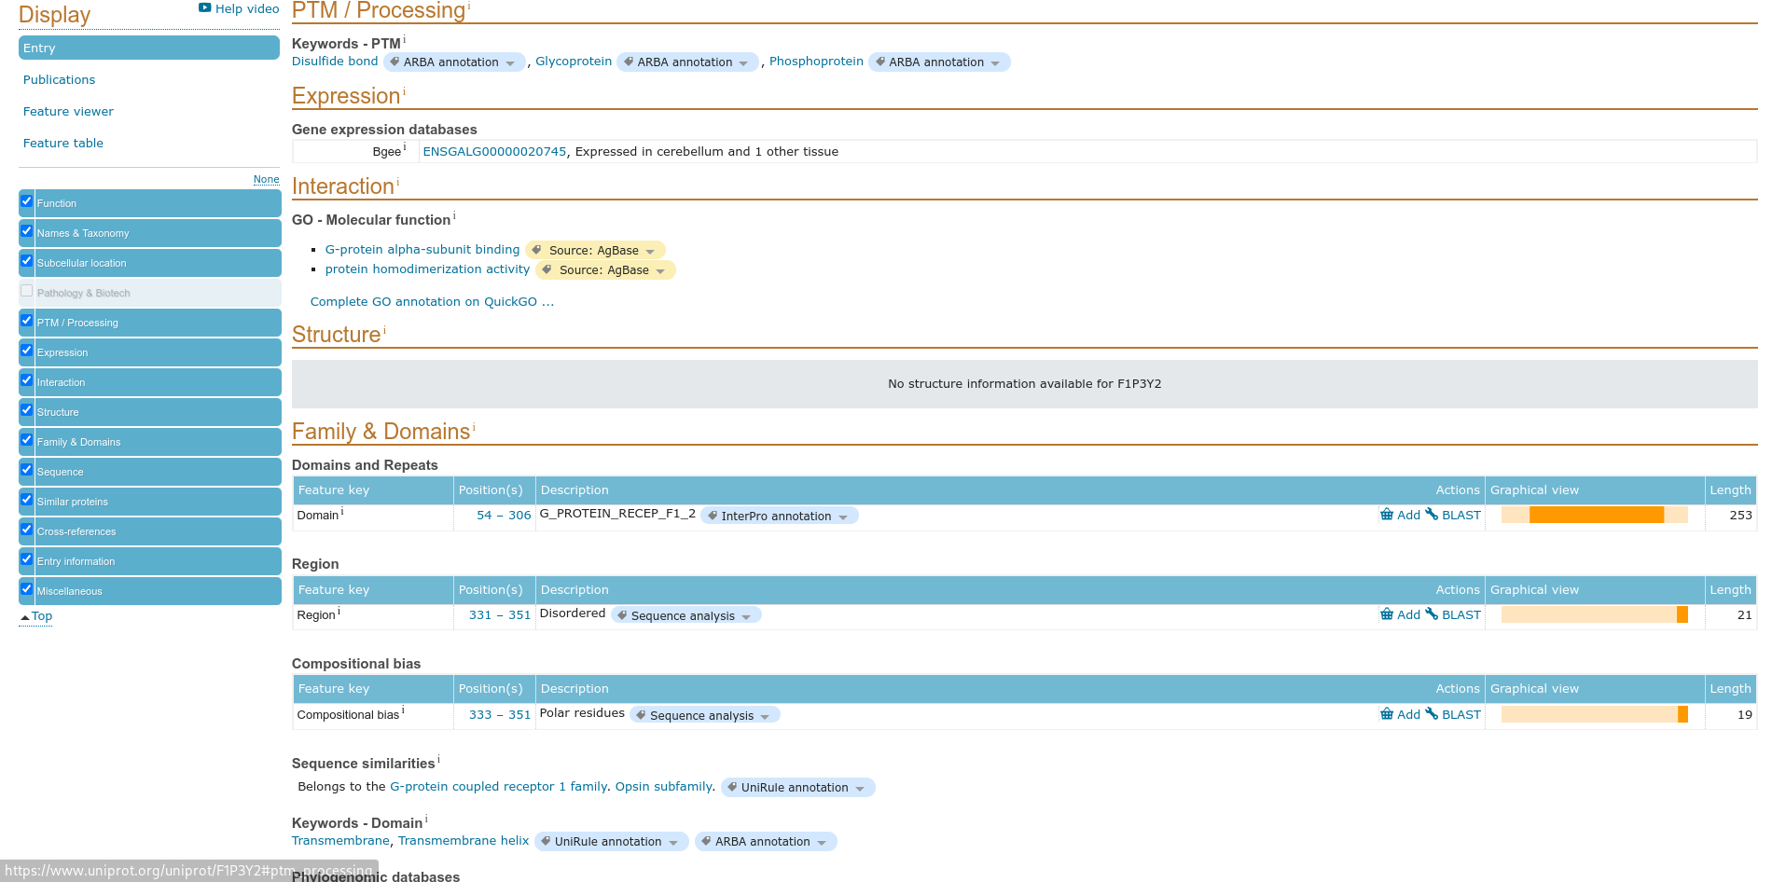
Fig8. PTM processing for result of query Rhodopsin

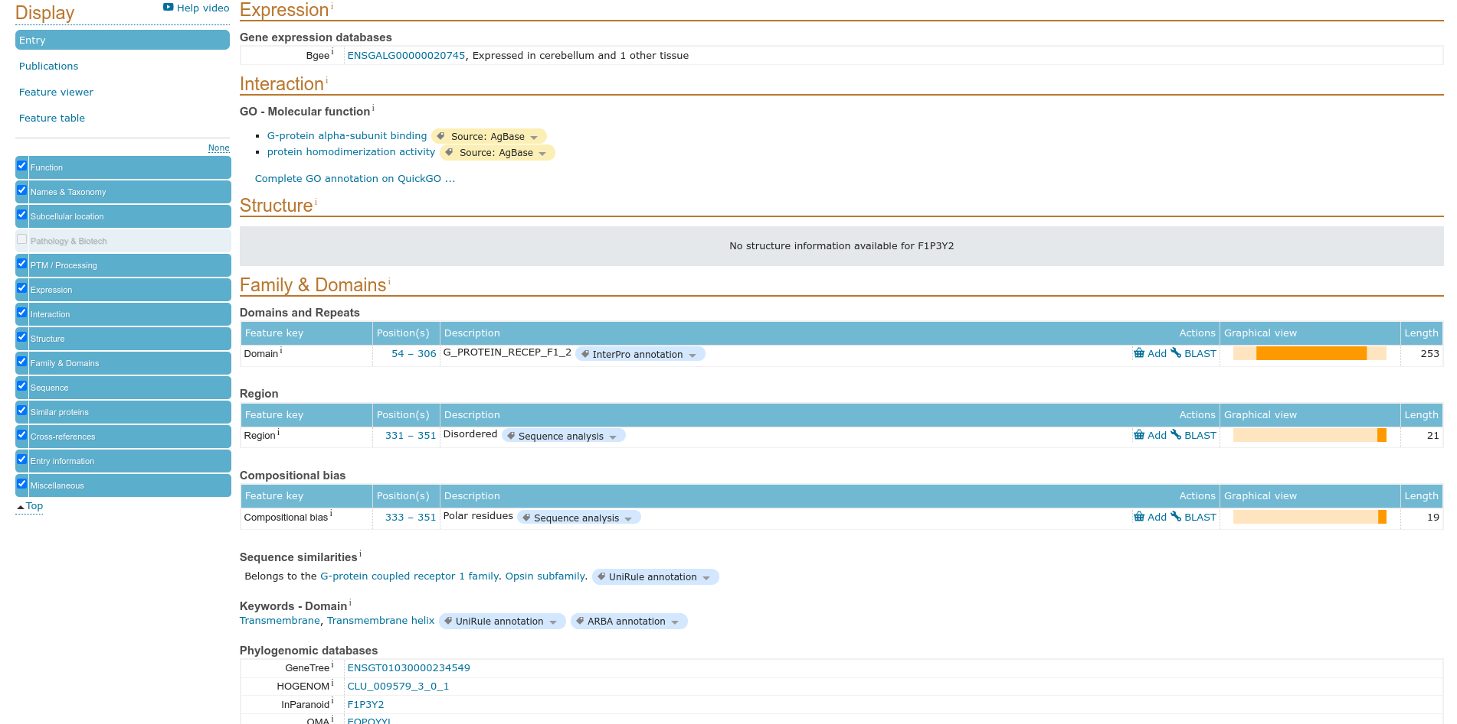
Fig9. Expression for result of query Rhodopsin

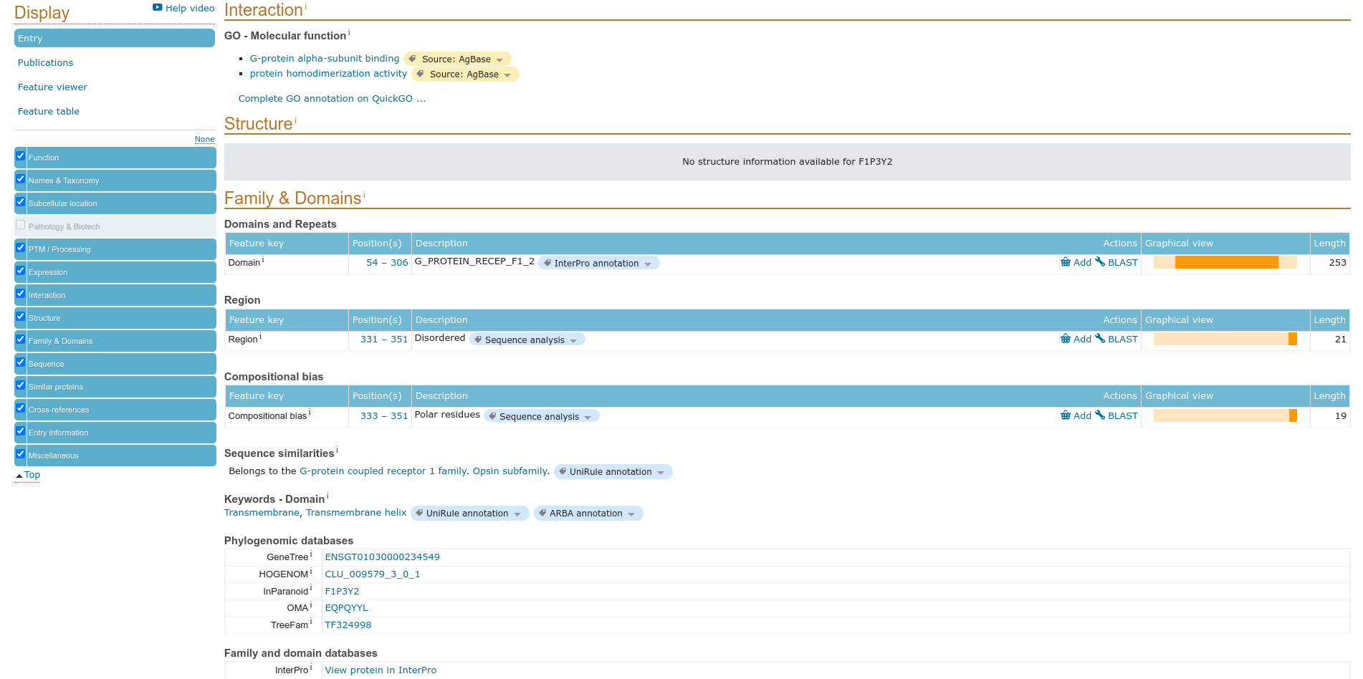
Fig10. Interaction for result of query Rhodopsin

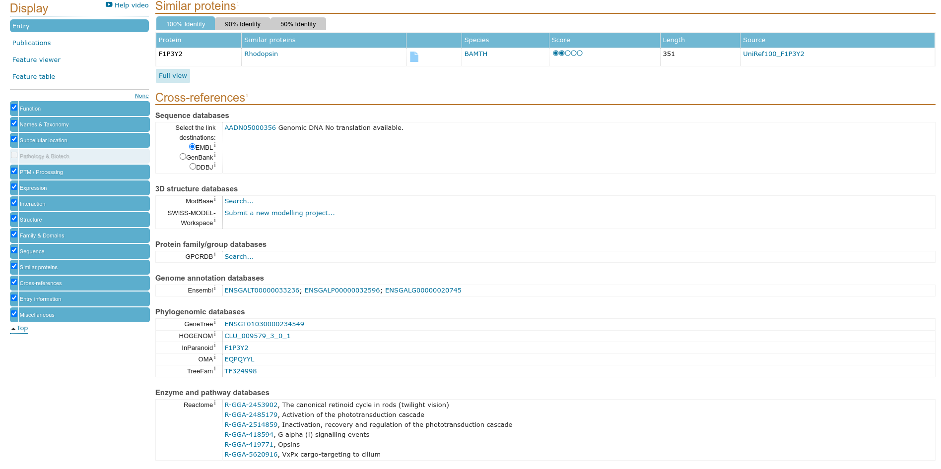
Fig11. Similar proteins for result of query Rhodopsin

Results:

In UniprotKB it consist TrEMBL that is Unreviewed paper and for the query ‘Rhodopsin’ is
contain 54,696 papers

Conclusions:

A computer annotated supplement to Swiss-Prot .Contains all the translations of EMBL
nucleotide sequences entries not yet integrated in Swiss-Prot and cross-referenced to many
other databases.

References:

- https://www.uniprot.org/
- https://www.uniprot.org/uniprot/?query=rhodopsin&fil=reviewed%3Ano&sort=score
- https://www.uniprot.org/uniprot/F1P3Y2
- https://www.uniprot.org/uniprot/F1P3Y2#function
- https://www.uniprot.org/uniprot/F1P3Y2#names_and_taxonomy
- https://uniprot.org/uniprot/F1P3Y2#subcellular_location
- https://www.uniprot.org/uniprot/F1P3Y2#ptm_processing
- https://www.uniprot.org/uniprot/F1P3Y2#expression
- https://www.uniprot.org/uniprot/F1P3Y2#interaction
- https://www.uniprot.org/uniprot/F1P3Y2#similar_proteins
- https://www.uniprot.org/uniprot/F1P3Y2.fasta

Date: 29-09-21
WEBLEM 4d
(URL: https://www.uniprot.org/)

Aim:

To study ‘Rhodopsin’ Protein information using PIR Database: An Integrated Protein Informatics Database.

Introduction:

The Protein Information Resource (PIR) is an integrated public bioinformatics resource to support genomic, proteomic and systems biology research and scientific studies (Wu et al., 2003). PIR was established in 1984 by the National Biomedical Research Foundation (NBRF) as a resource to assist researchers in the identification and interpretation of protein sequence information.

Rhodopsin is a biological pigment found in the rods of the retina and is a G-protein-coupled receptor (GPCR). It belongs to a group of photoswitchable opsins. Rhodopsin is extremely sensitive to light, and thus enables vision in low-light conditions. When rhodopsin is exposed to light, it immediately photobleaches.

Methodolgy:

- Homepage of Uniprot.
- Enter the UniprotKB and search the query ‘Rhodopsin’
- Interpret the results.

Observations:

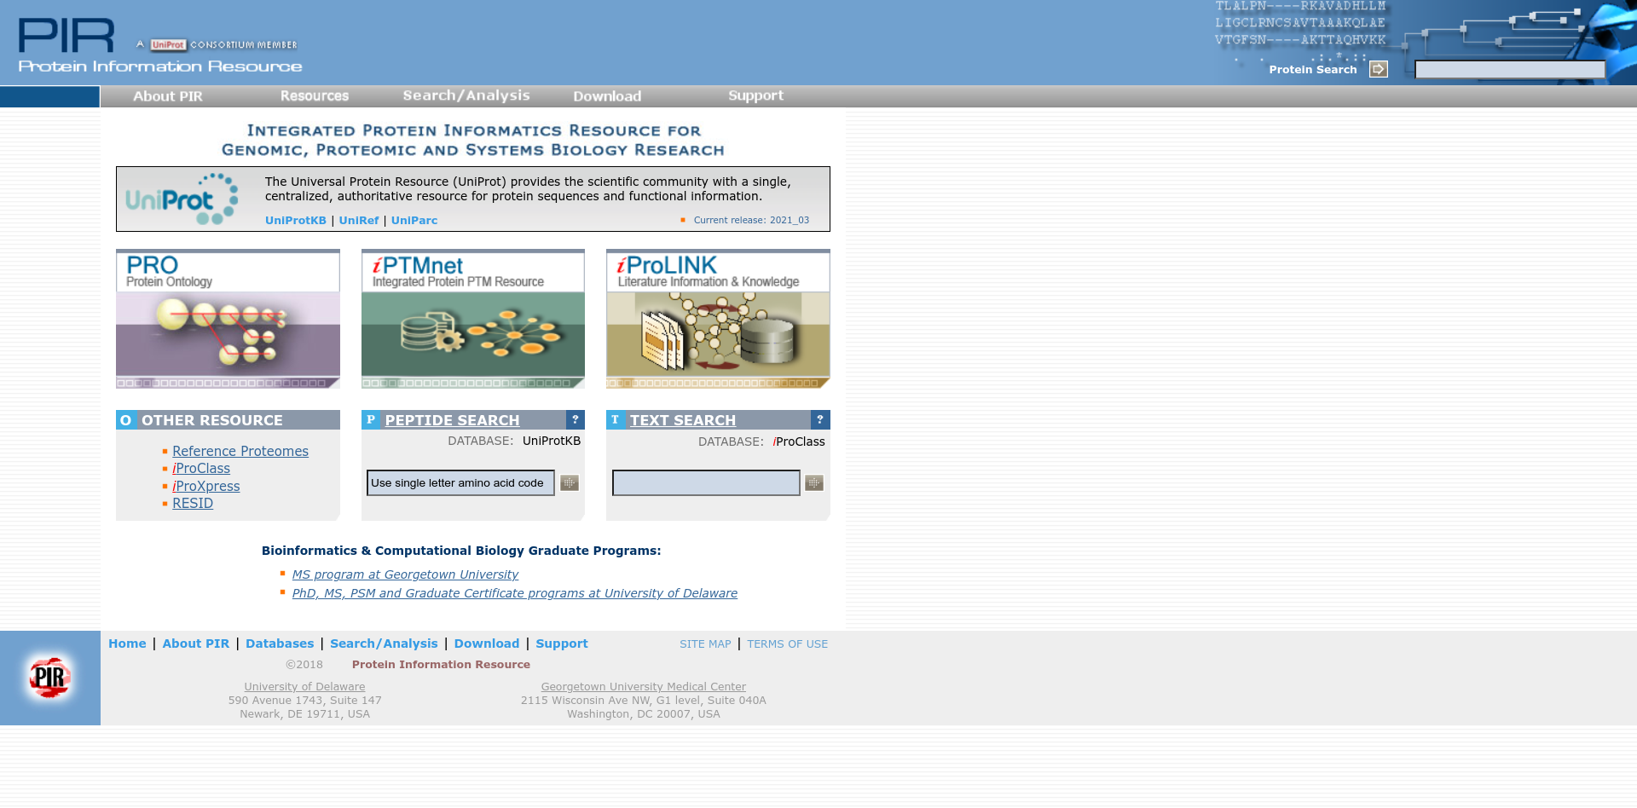
Fig1. Homepage of PIR
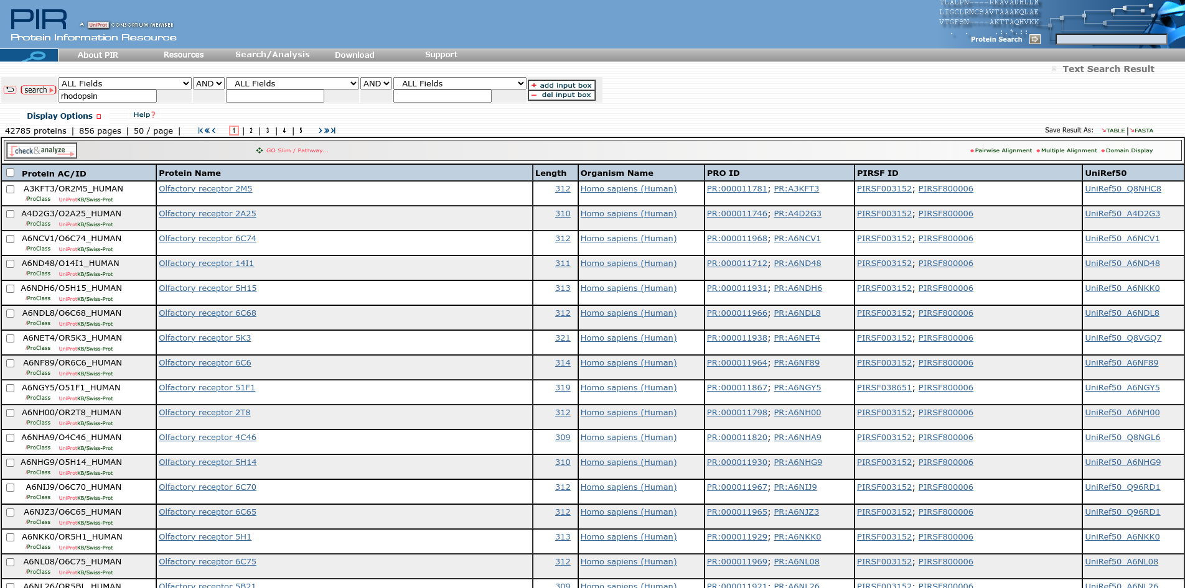
Fig2. Hit page for PIR for query Rhodopsin

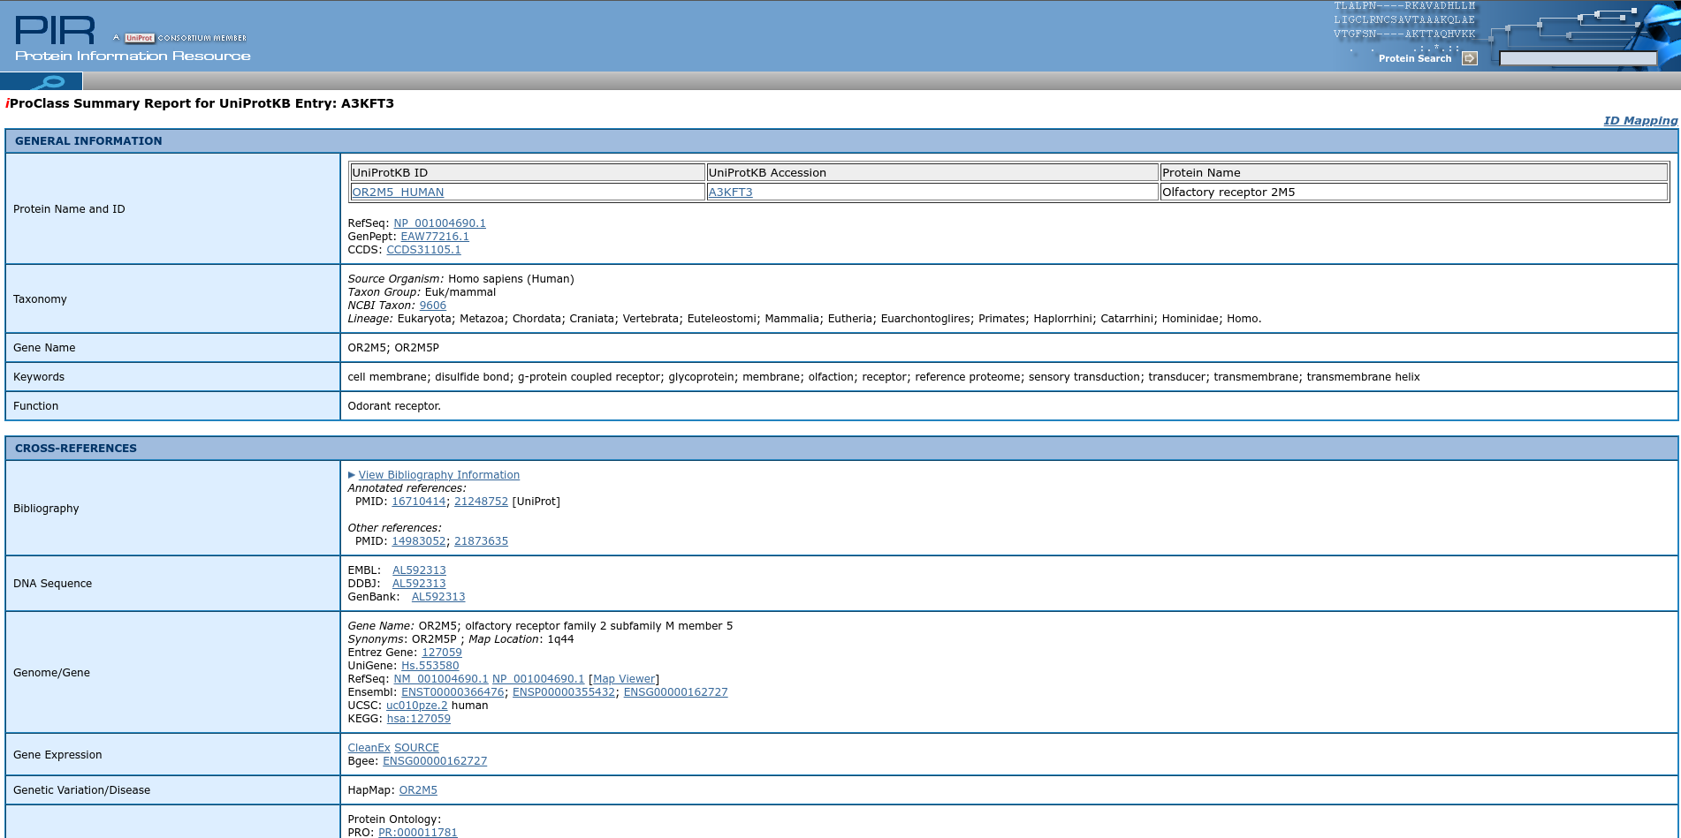
Fig3. Result page for query Rhodopsin

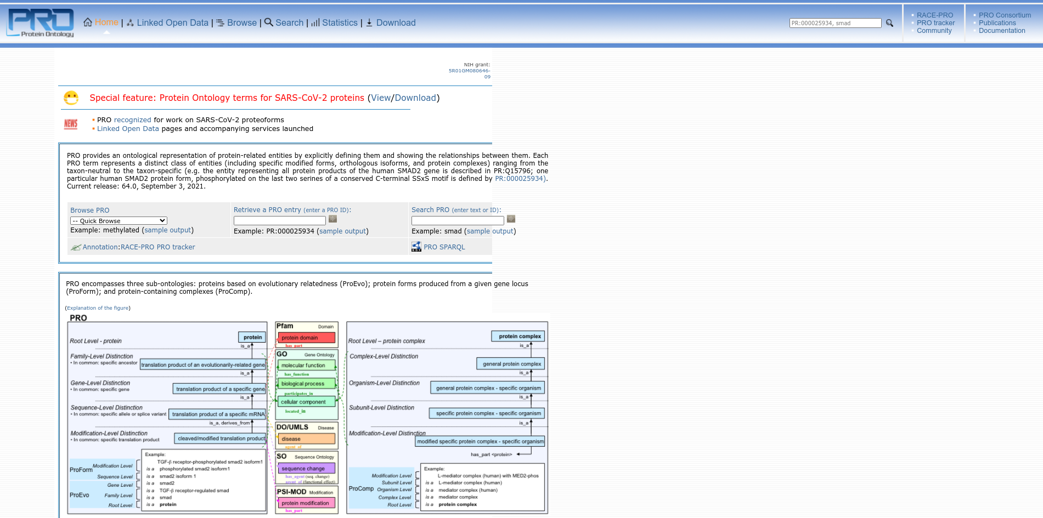
Fig4. Home page of PRO with PR ID

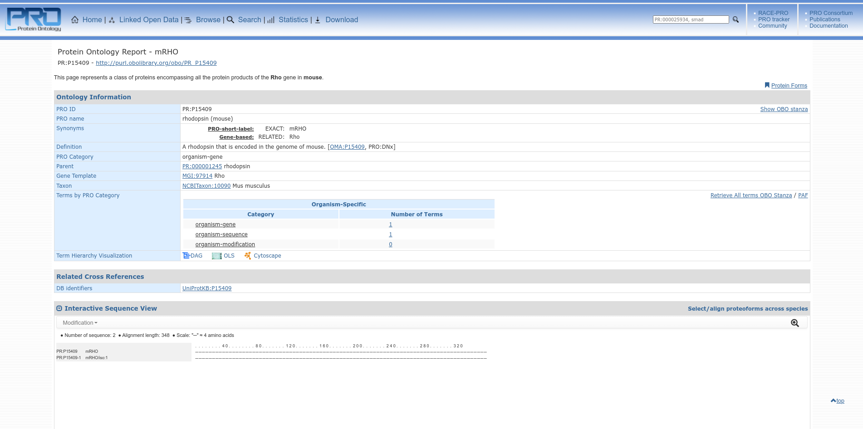
Fig5. Result page of PRO for query rhodopsin

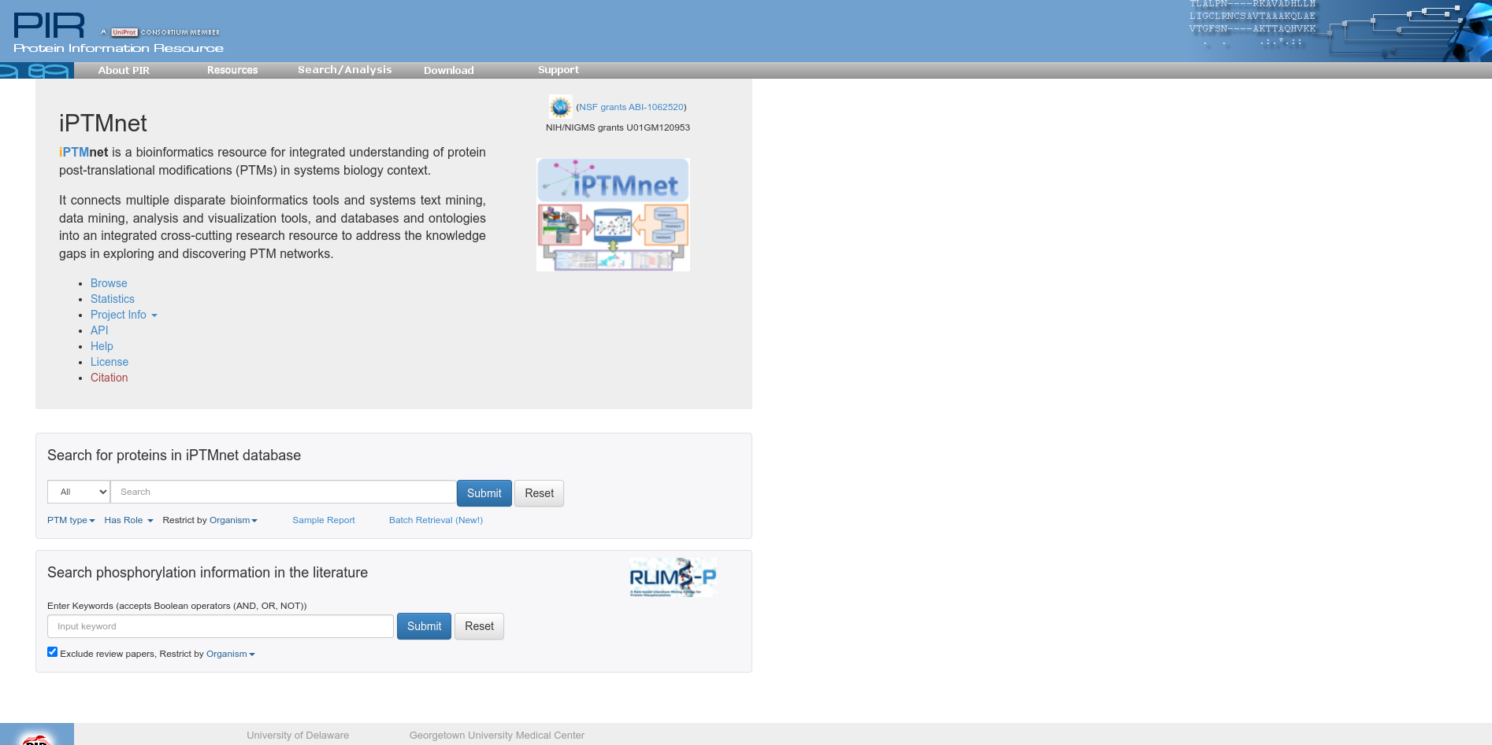
Fig6. Home page of iPTMnet for query Rhodopsin

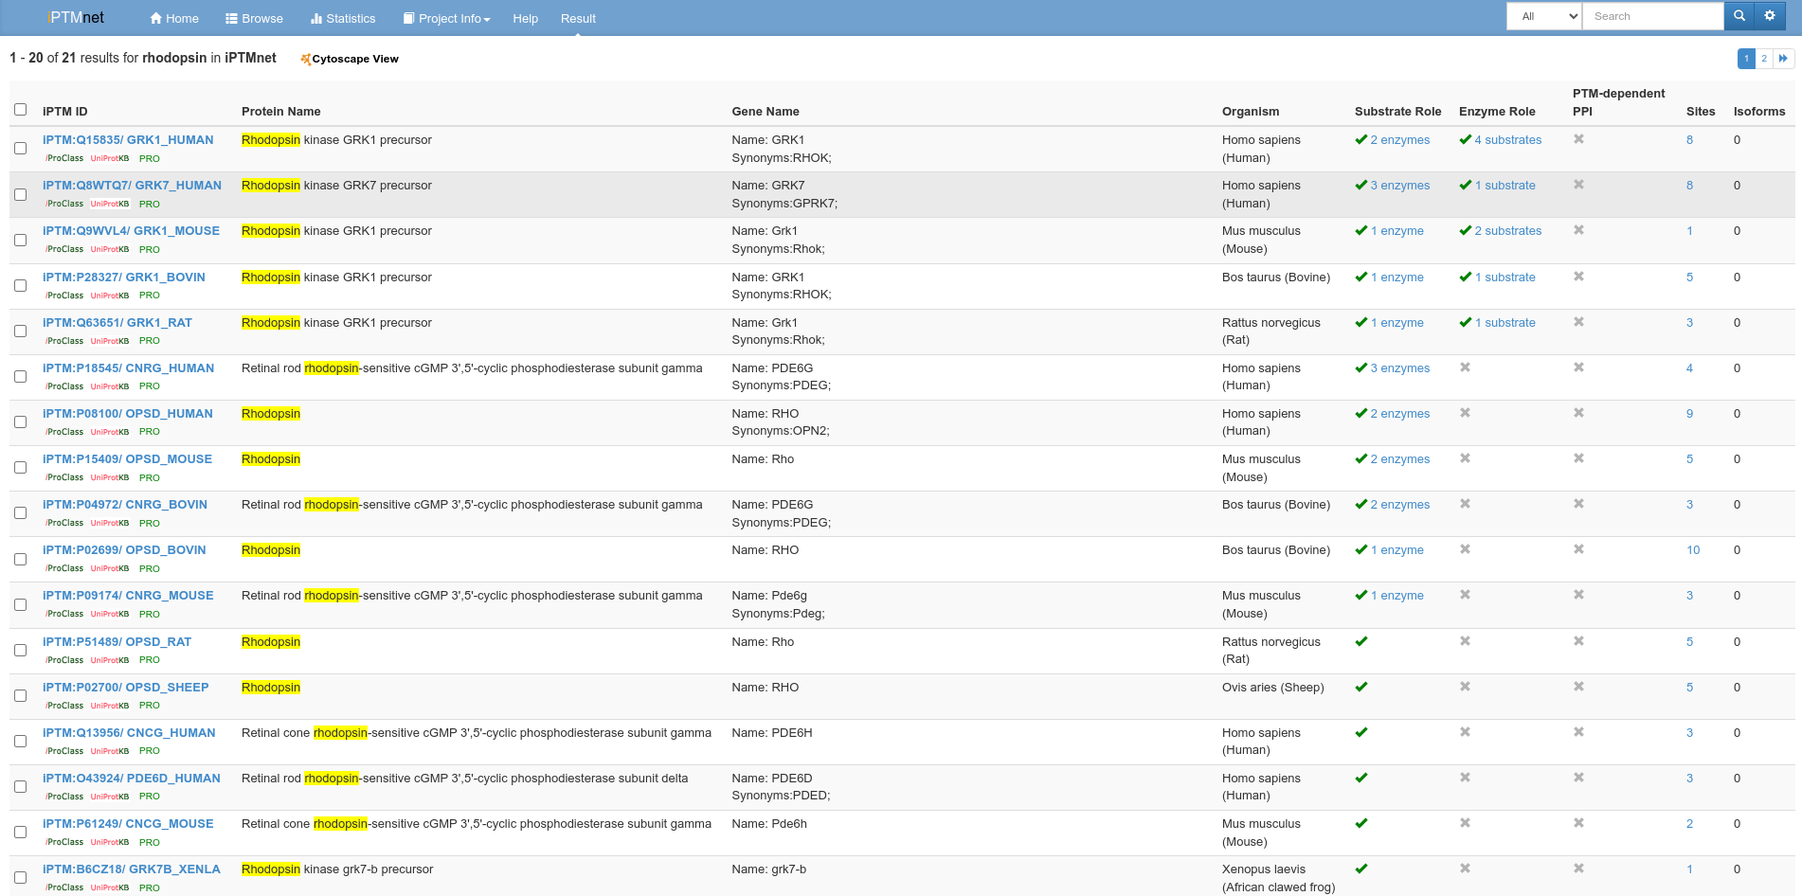
Fig7. Hit page for query Rhodopsin in iPTMnet

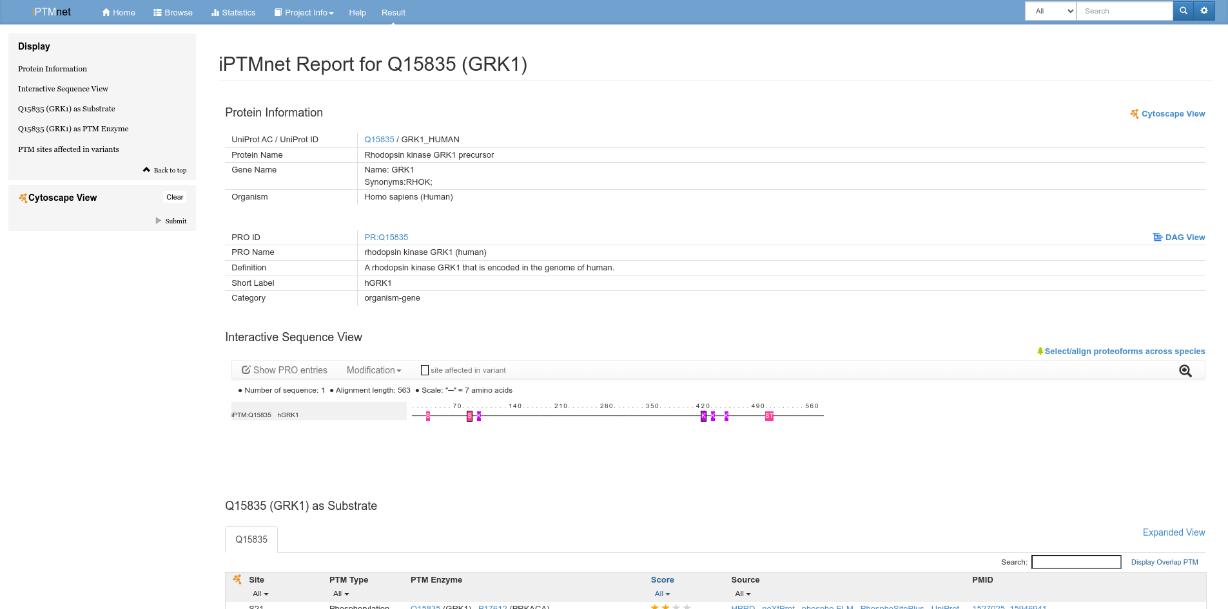
Fig8. Result page for query Rhodopsin in iPTMnet

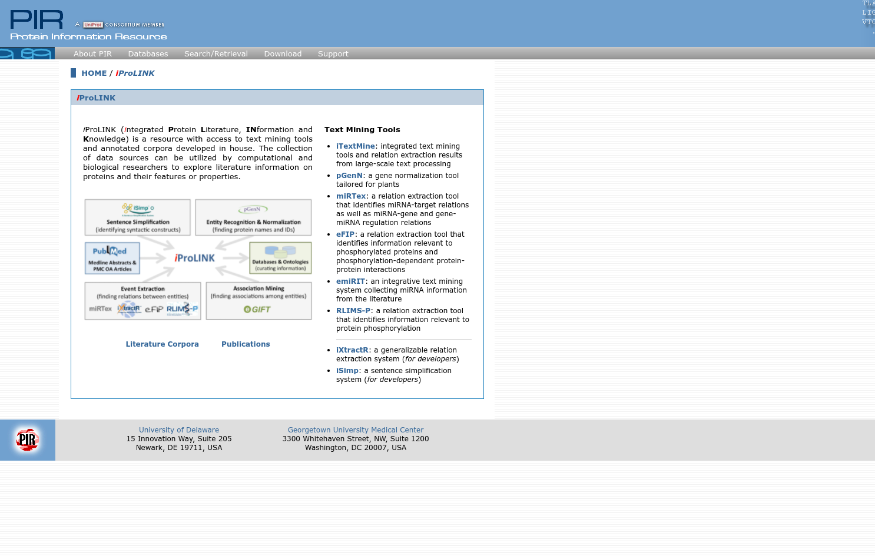
Fig9. Home page for iProLINK

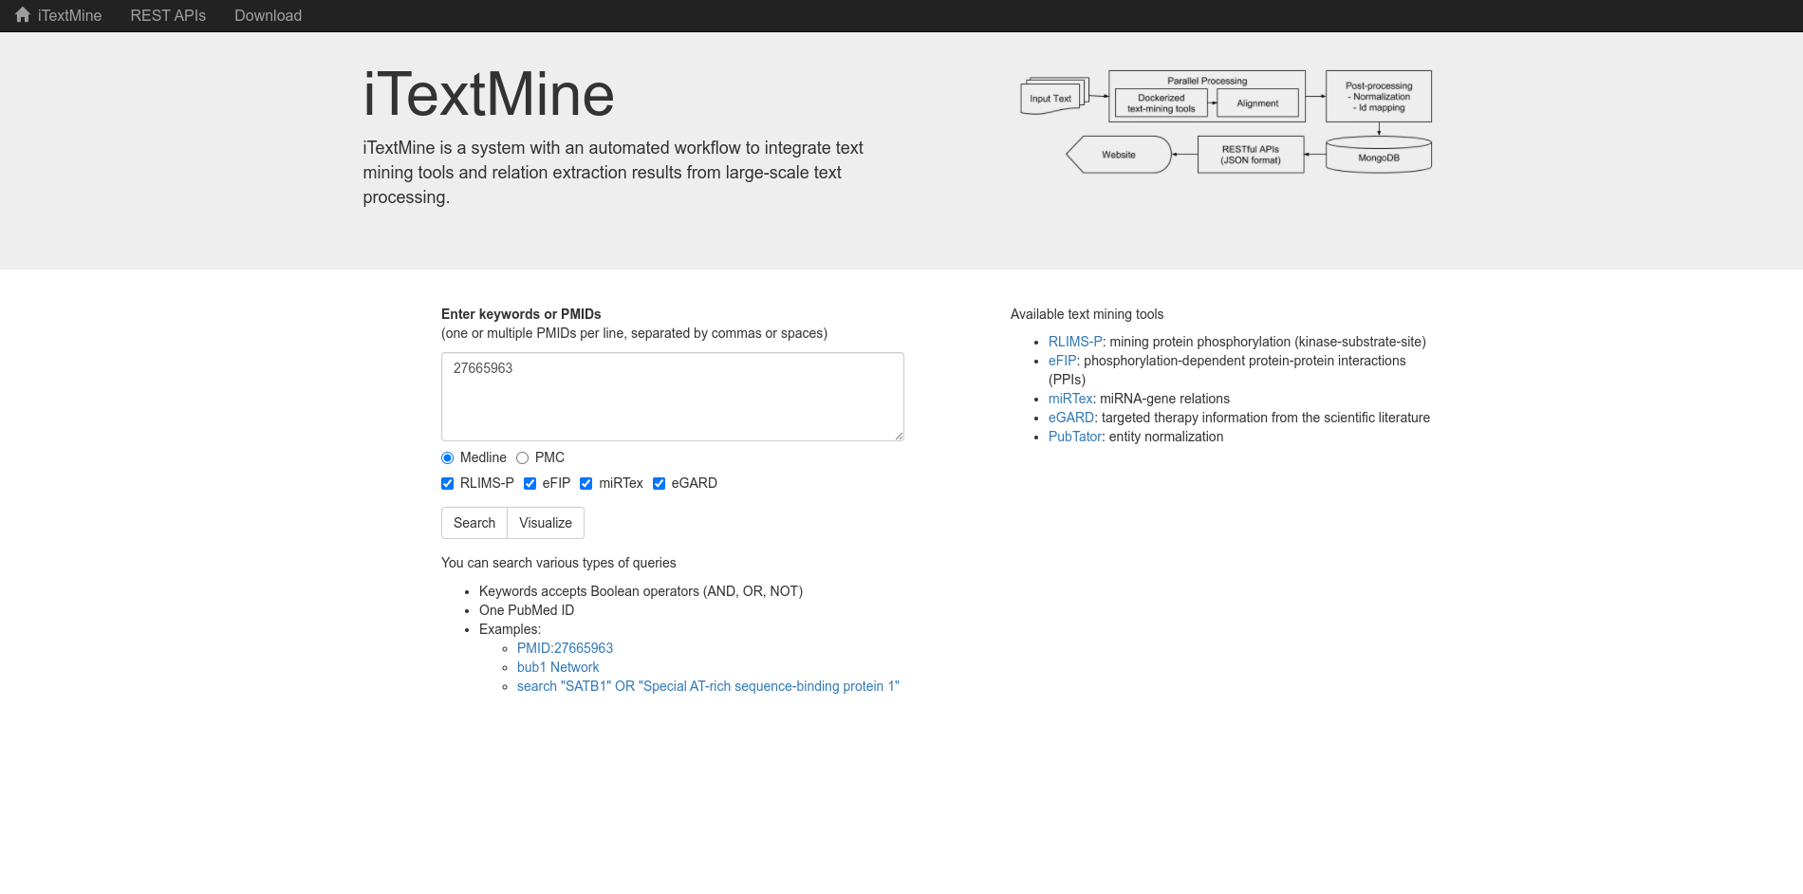
Fig10. ItextMine page for iProLINK with PMID.

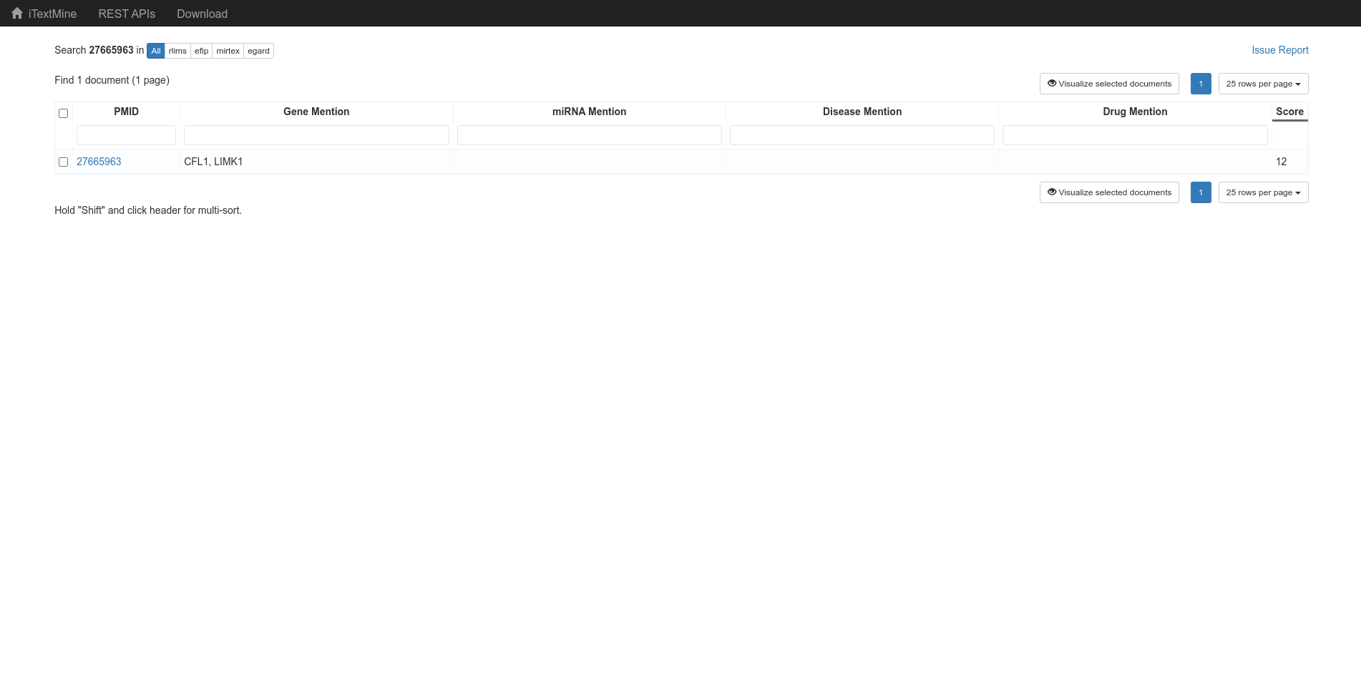
Fig11. Hit page for query Rhodopsin with PMID

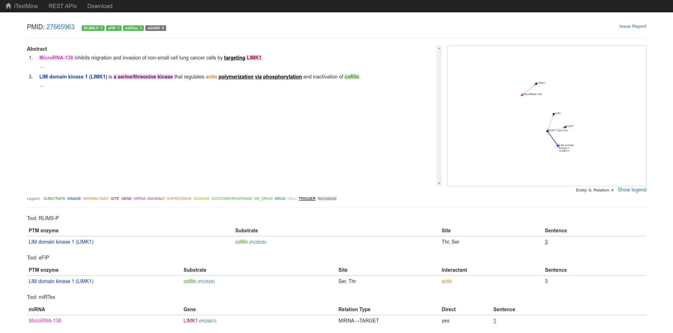
Fig12. Result of query Rhodopsin in iTextMine with PMID

Results:

PIR has similar database but from different resources and integrated resources . In one domain can read all resources and it can be use as a cross references . In PRO entring the PRO ID can search the paper and from iProLink in iTextMine can search the paper by entring the PubMed ID .

Conclusion:

The PIR(Protein Information Resources) maintains several databases about proteins. Its integrated public bioinformatics resources to support genomic and proteomic research , and scientific studies.

References:
- https://proteininformationresource.org/cgi-bin/textsearch.pl?submit.x=0&submit.y=0&query0=rhodopsin&field0=ALL&search=1
- https://proteininformationresource.org/cgi-bin/ipcEntry?id=A3KFT3
- https://proconsortium.org/pro.shtml
- https://proconsortium.org/cgi-bin/textsearch_pro?search=search&field0=ALLFLDS&query0=rhodopsin&search.x=0&search.y=0
- https://proconsortium.org/app/entry/PR:P15409/
- https://research.bioinformatics.udel.edu/iptmnet/
- https://research.bioinformatics.udel.edu/iptmnet/search/all/rhodopsin/mod-ac%2Cgn%2Cgo%2Cgc%2Cgs%2Cme%2Cmy%2Cp%2Csu%2Cub%2Csno/
- https://research.bioinformatics.udel.edu/iptmnet/entry/Q15835/
- https://research.bioinformatics.udel.edu/iprolink/
- https://proteininformationresource.org/itextmine/
- https://research.bioinformatics.udel.edu/itextmine/integrate/doc/rlims-efip-mirtex-egard/medline/27665963

